**Want Fish?**

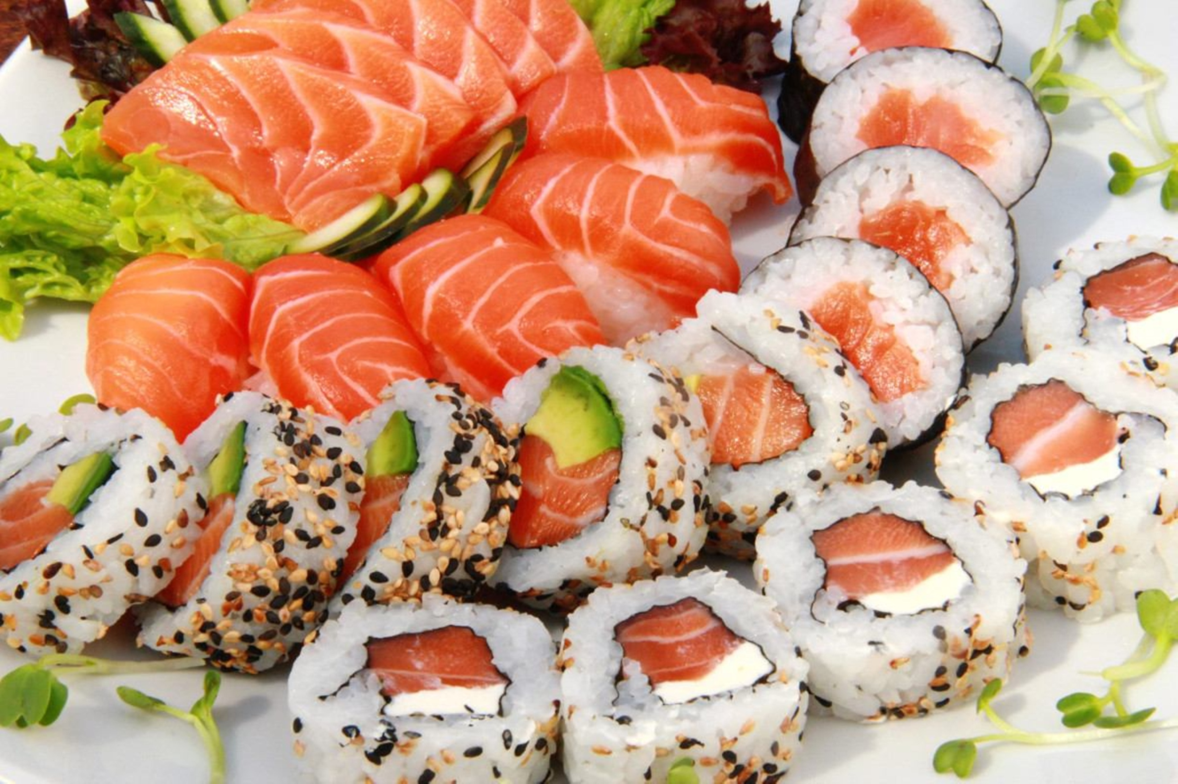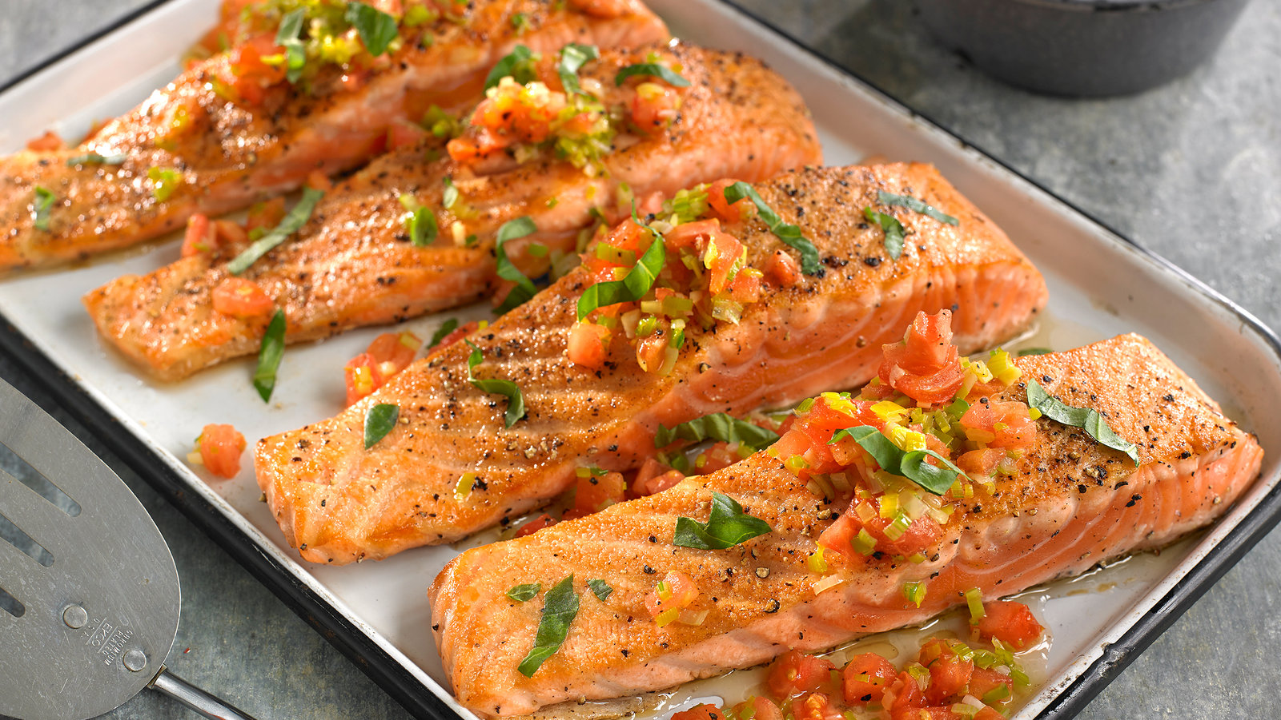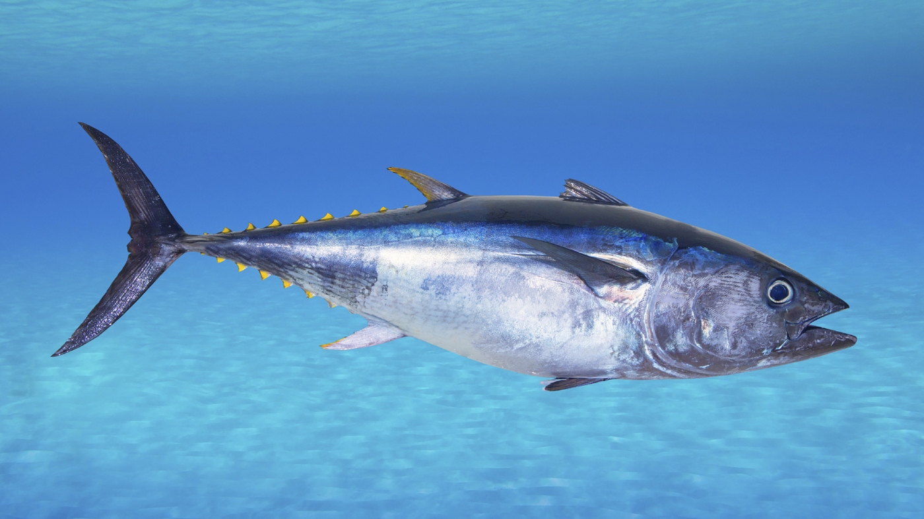

What Can You Do?

* If you are shopping for fish at a grocery store look for sustainability labels such as this one
* For both restaurants and grocery stores you can use the **Montgomery Bar Aquarium Seafood Watch App** which is free to download and use to see if your sushi or salmon were sustainably caught and if not direct you to an establishment or brand that does use sustainable fisheries.
* If you are in the mood for a rainbow trout or walleye instead of buying it at your local King Soopers go fishing. The great state of Colorado is also a fantastic place to fish for your own meal. Go out and enjoy the beautiful reservoirs, streams, and lakes that this state has to offer. **Cpw.state.co.us/thingstodo/Pages/Fishing.aspx** is a great place to get started if you decide that fishing sounds like a fun weekend activity.

Problem of Overfishing

1. Harms the Ocean Ecosystems
2. Hurts animals that are not being fished such as dolphins and sea turtles
3. Many people depend on fishing as a livelihood if we continue to decimate the oceans they will have no source of income

It may not seem like overfishing is a problem for people living in the great state of Colorado but if you love eating fish and would like to continue to be able to enjoy it follow the simple guidelines above. You can help solve this problem one person at a time!