Organizations Working at a Solution and how you can help:

There are hundreds of organizations that dedicate themselves to researching and conserving these coral reefs. The research allows for us to see how the coral reefs are responding to the threats they face and how we can help in the future. If you want to help, go donate to foundations that do this research or conservation. Below are some of these programs and websites for more information on the topic.

Educational websites:
- https://oceanservice.noaa.gov/education/tutorial_corals/coral11_protecting.htm
- https://coralreef.noaa.gov/

Donate:
- Coral Reef Alliance
- Oceana
- The Ocean Conservancy
- Coral Restoration Foundation

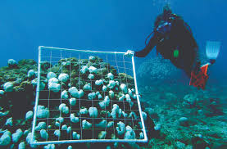

References:

Drury, C. (2019). Resilience in reef‐building corals: The ecological and evolutionary importance of the host response to thermal stress. Molecular Ecology. doi: 10.1111/mec.15337

Rodriguez-Casariego, J. A., Ladd, M. C., Shantz, A. A., Lopes, C., Cheema, M. S., Kim, B., ... Eirin-Lopez, J. M. (2018). Coral epigenetic responses to nutrient stress: Histone H2A.X phosphorylation dynamics and DNA methylation in the staghorn coral Acropora cervicornis. Ecology and Evolution, 8(23), 12193–12207. doi: 10.1002/ece3.4678

Ayre, D. J., & Hughes, T. P. (2000). Genotypic diversity and gene flow in brooding and spawning corals along the Great Barrier Reef, Australia. Evolution, 54(5), 1590–1605. https://doi.org/10.1111/j.0014-3820.2000.tb007Ayre, D. J., & Hughes, T. P. (2004). Climate change, genotypic diversity and gene flow in reef‐building corals. Ecology Letters, 7(4), 273–278. https://doi.org/10.1111/j.1461-0248.2004.00585.x

LaJeunesse, T. C., & Thornhill, D. J. (2011). Improved resolution of reef-coral endosymbiont (Symbiodinium) species diversity, ecology, and evolution through psbA non-coding region genotyping. PloS one, 6(12), e29013. https://doi.org/10.1371/journal.pone.0029013

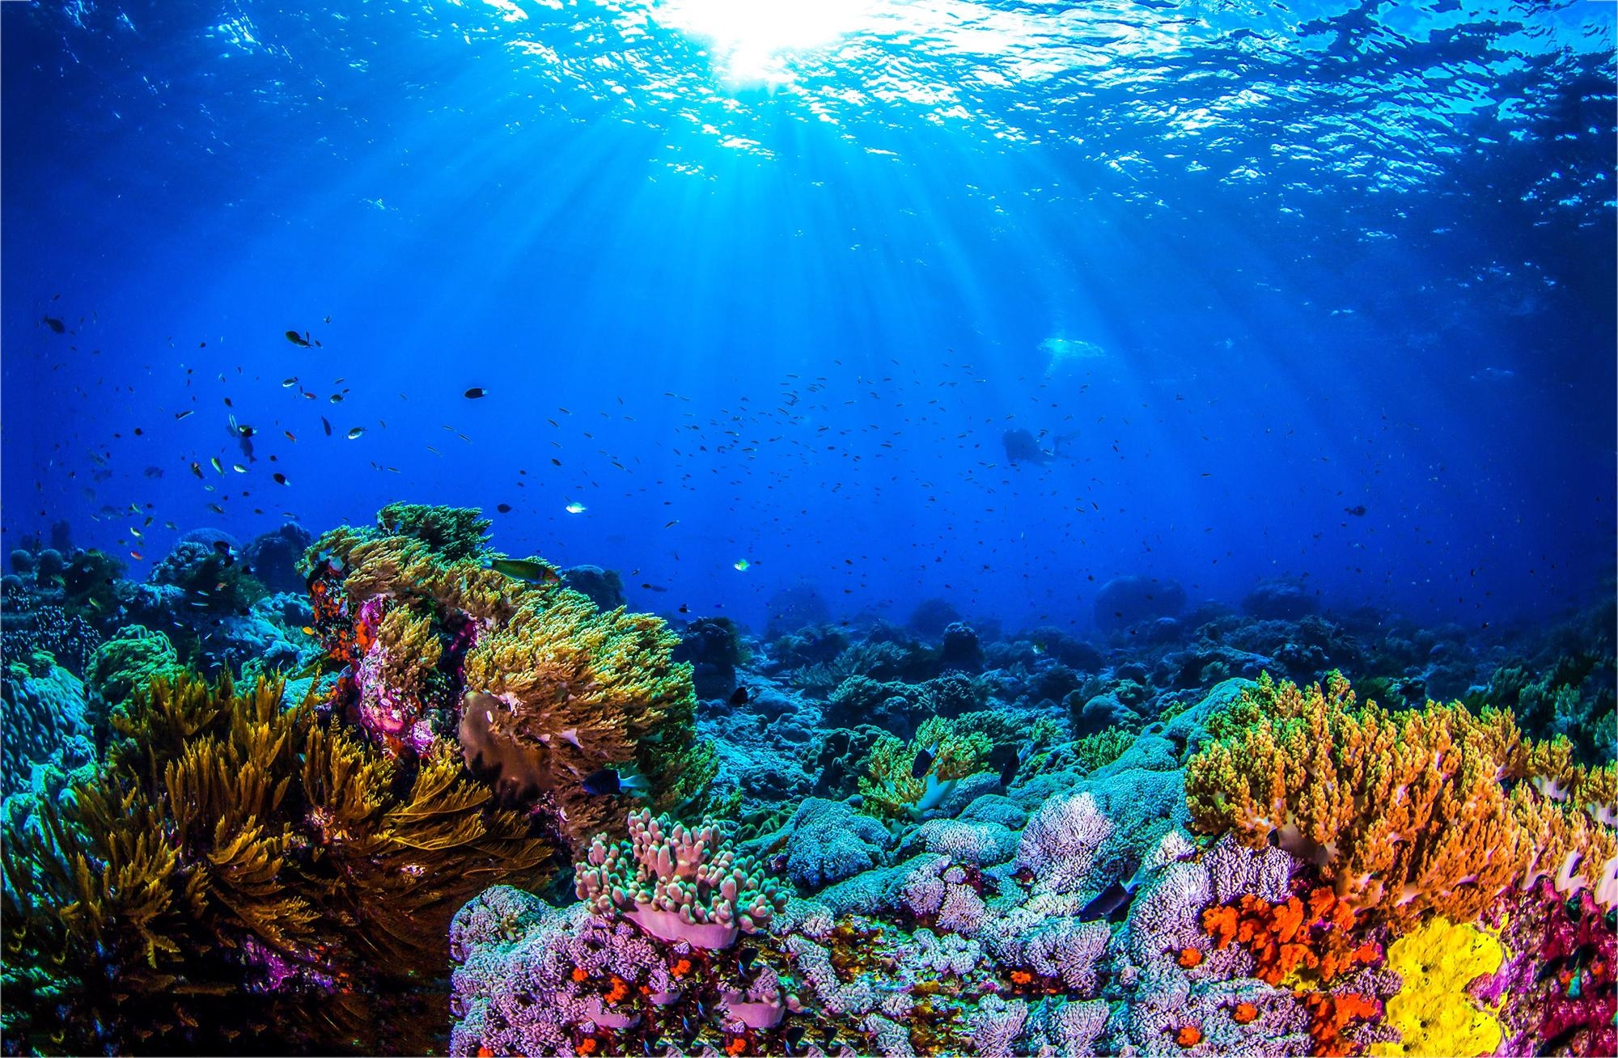
Coral Reef Disaster
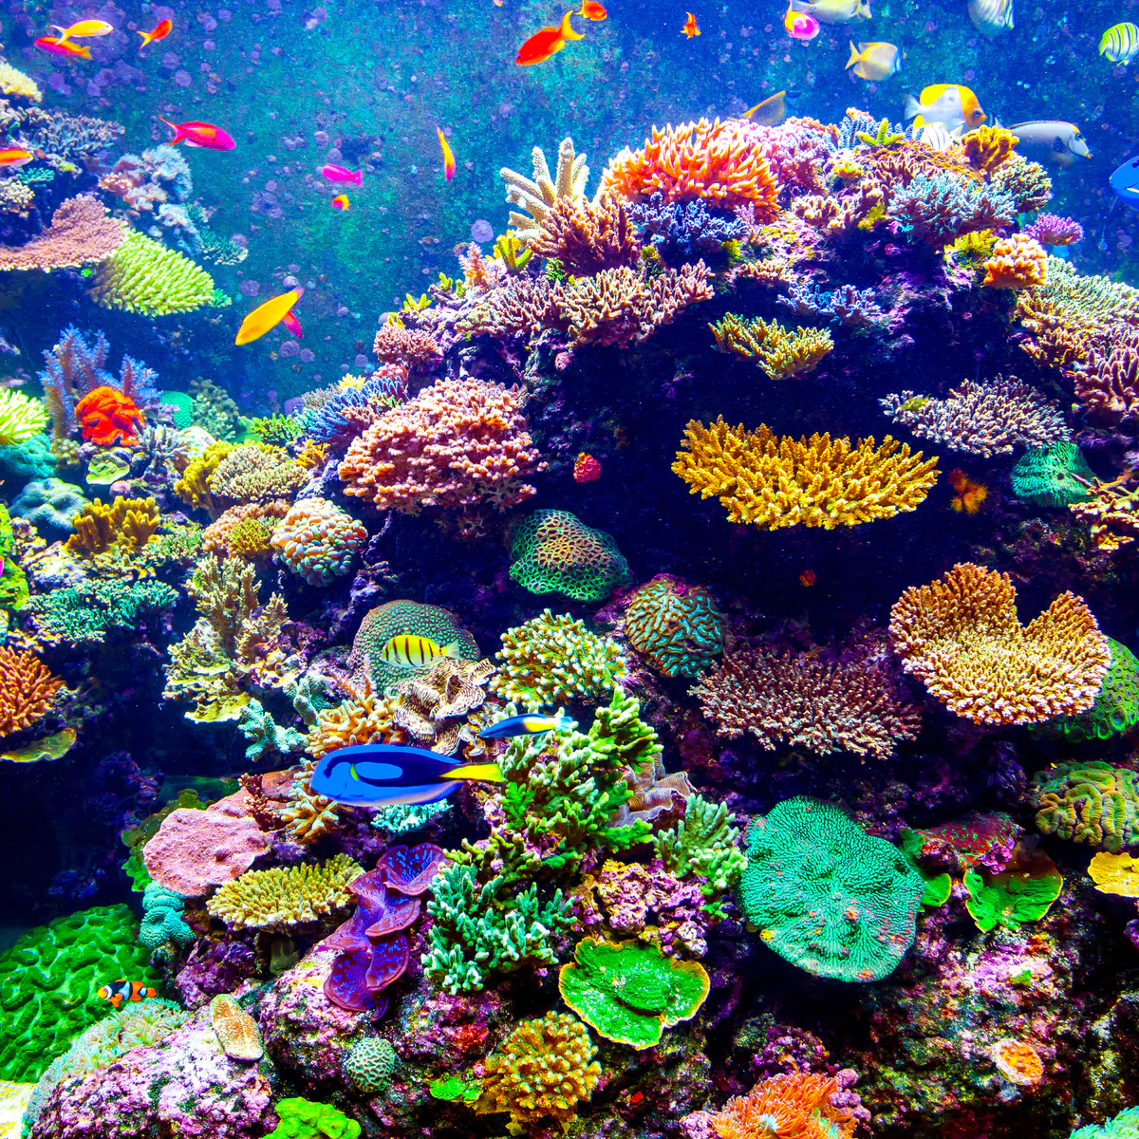
Why is the coral reef necessary?
Coral reefs provide shelter and nutrients for different types of marine life. It is an ecosystem that sustains a large and diverse portion of marine life. The coral reef provides millions of people with food. How? The coral reef serves as a nursery for many species that we consume. These include crabs, lobster, grouper and snapper. Some species that come from these reefs feed communities all around the world. Without the coral reef, we wouldn't have as many types of fish to eat or even shrimp. The coral reef gives a safe place full of nutrients to marine life and allows it to flourish so much that we can have fisheries and a source of food.
What Is happening to these coral reefs and what is this impact?
There are many threats to the coral reef including nutrients pollution and thermal stress. If there is too much nutrients in the water which can make the water quality bad and decrease oxygen levels. Nutrients pollution can also cause extreme algae growth that over crowds and “suffocates” the corals. Thermal stress or an increase in temperature can cause bleaching in coral reefs due to the breakdown of the relationships between corals and their symbionts. Both of these harmful environmental factors can kill off coral reefs and in turn this takes away a vital habitat for many marine species.
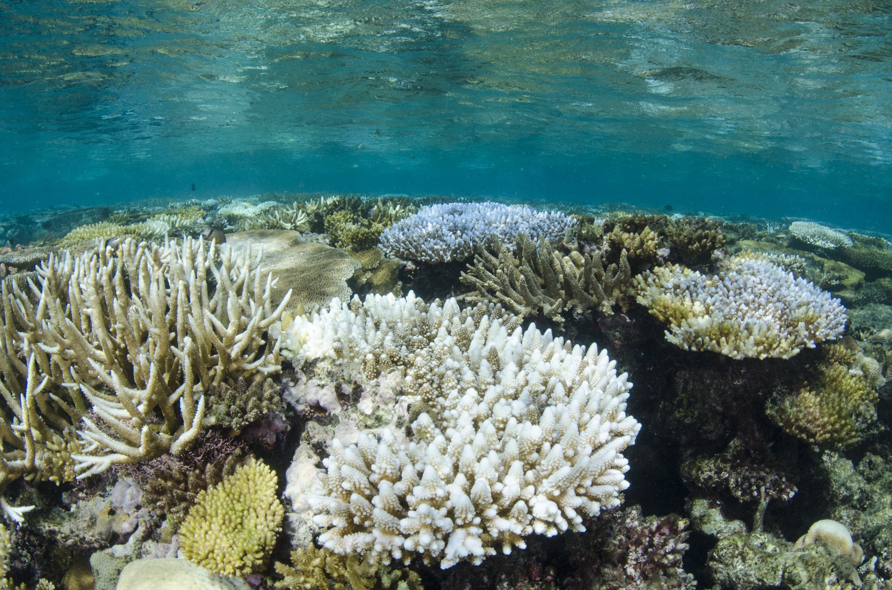
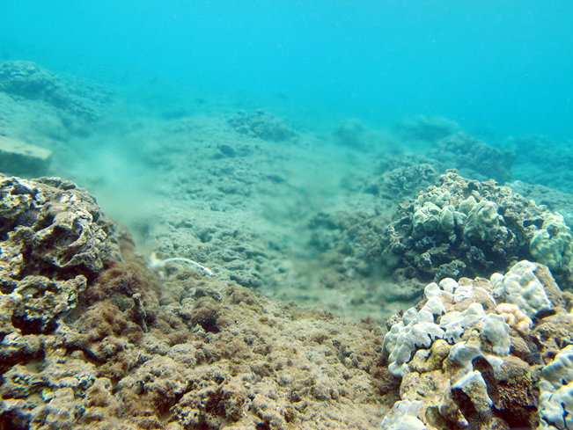
Solutions
Researchers are investigating the host response to temperature stress and how genomic differences can be inherited in order to rebuild coral reefs that can be resilient to thermal stress and nutrients pollution. All of this is possible through genetic variability and flow. They have also researched the epigenetic response that coral species has to these two threats. It pulls away from gene alterations for a solution and also goes towards phosphorus improving tolerance and resilience to both of these threats.
The reproduction or different species found in coral reefs were studied to see how genetic diversity and dispersal of the larvae can also help solve this problem. The researchers observed that generations became more tolerant of the threats they face. Larvae dispersal is important in preventing extreme damage made by the dangerous biological changes happening because of global warming. The dispersal of larvae encourages new growth and development on coral reefs and hopefully they can begin to evolve in a way that allows them to survive. They are necessary for gene flow when species start to be affected. It goes on to say that without long-distance dispersal of corals that are geographically isolated, they can become vulnerable to global warming. Coral’s genetic flow can affect the range of damage from global warming threats and how they have natural systems to help them survive.

