# Process

Runoff finds its way into streams, lakes, ponds, or any type of body of water. In the runoff, there's an excess of water-soluble phosphorus which causes a vast amount of algal or bacteria growth. These algal blooms prevent sunlight from reaching a lake or water body resulting in the death of aquatic plants. Low O2 levels in the water cause the death of fish and other aquatic life.

# Human Causes

We contribute to this problem by mining phosphorus then transporting it in fertilizers, animal feed, agricultural crops and other products. All of this alters the Phosphorus cycle which causes phosphorus to accumulate in the world’s soil.

## 

## **Eutrophication – What is it?**

It’s excessive richness of nutrients in a lark or other body of water, due to runoff from the land. This causes a dense growth of plant life and death of fish and aquatic plants from a lack of oxygen.

# Why should you care?

People that live in Colorado should care about the effects of eutrophication because it can affect the lakes that some of the people have in their backyards, or the lakes that they love to go fish at during their free time. In addition, since it decreases the amount of oxygen that fish/marine life receives, it can hurt the economy and the fishing industry.

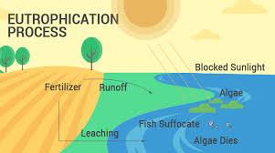

**Before 🡪 After**

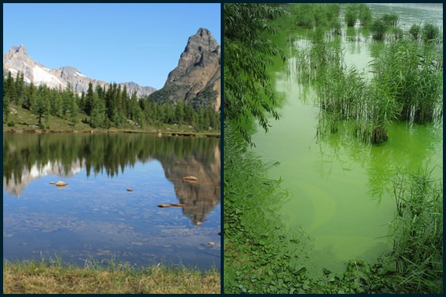

**“The best time to plant a tree is twenty years ago. The second best time is now.”**

* **Chinese Proverb**

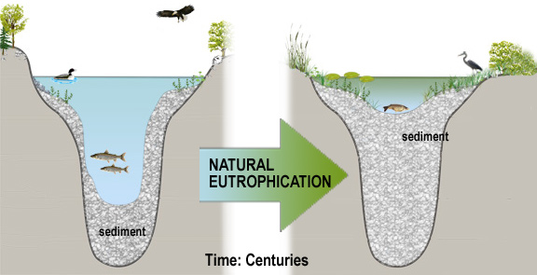

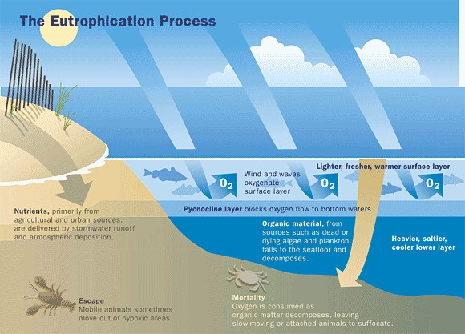

Kaylee Luck

CSU

Marine Biology

# Solution

Plant more trees. Trees act as natural filters to protect lakes, streams, and rivers. Their roots can help stabilize soil and prevent contaminated soil particles from washing into water supplies.

Specifically, plant more trees in between farmland and water courses or lakes so that they can soak up nutrients.