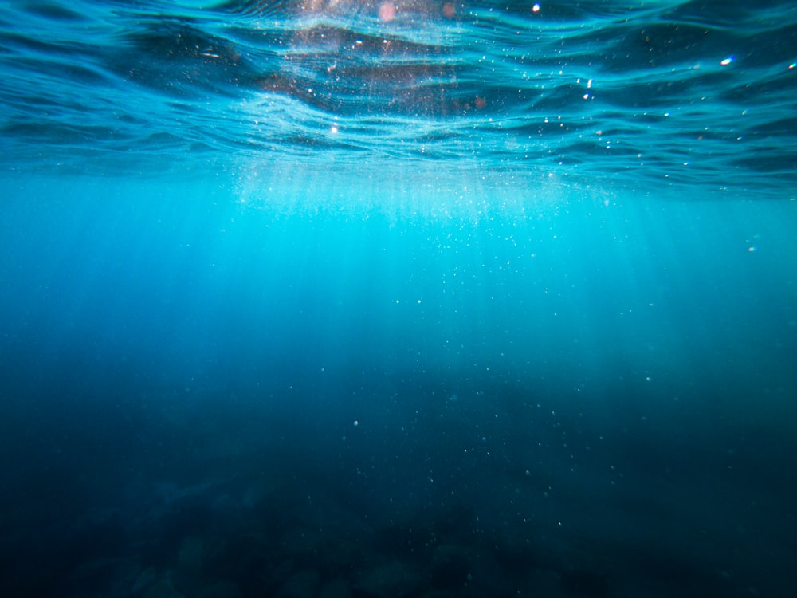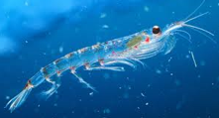

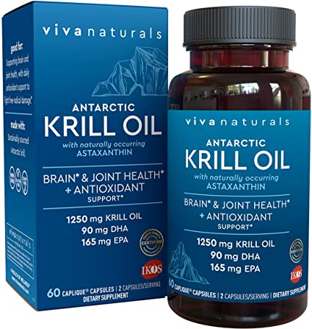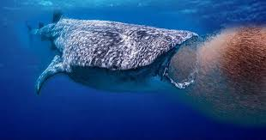

A HEALTHY OCEAN BASIN COULD FEED 1 BILLION PEOPLE ONE NUTRITIOUS MEAL PER DAY

thus, solving global hunger issues now or supplying a larger global population in the future

* The current population on earth is about 7.53 billion people. This population is predicted to reach 9 billion by the year 2050
* According to the World Hunger Statistics the Food Aid Foundation reports about 795 million people on earth struggle with hunger every year
* The United Nations Food and Agriculture Organization estimates food production will have to increase by 70% in order to sustain this rate of population growth
* Earth’s land mass most likely cannot sustain this demand, but ocean fishing requires no fresh water, doesn’t require arable land, and in general contributes fewer CO2 emissions into the atmosphere
* Krill are recognized as a keystone species and have the greatest biomass of any marine metazoan, making them globally important. Krill are a primary food source for fish, marine birds, and marine mammals in the Northern and Southern oceans. Therefore, the net impacts of removing excess krill biomass may have profound ecosystem impacts.
* Furthermore, krill allows the flux of carbon towards benthic habitats when its faeces sink into the sea floor, being an important agent in atmospheric carbon sequestration.
* From the year 2000 until 2017, krill fisheries effort and catch were concentrated in the Western Antarctic Peninsula and Southern Scotia Arc (where 83% of the krill catch to date has been taken). By concentrating all the catches in the same areas, overfishing may become a real issue because this region concentrates high abundances of krill‐dependent predators. Sustainable fishing practices to combat this issue would include creating an MPA (Marine Protected Area) in this region or requiring fishing vessels to fish larger geographic regions.
* Krill density is also highly dependent on sea-ice cover. Melting ice creates better year-round access to open water fishing for marine animals and commercial fishers which could put more pressure on krill populations. Sustainable fishing practices to combat this could include restraining commercial krill fishing to specific times during the year allowing populations to recover and reducing competition.
* Other sustainable practices:

Offering incentives to fishermen who adopt more sustainable fishing practices (reduced environmental impact/ lower fuel usage).

**Sustainable fishing practices = More food security**

* **KRILL:**

SUSTAINABLE FISHING

HOW TO MAKE IT HAPPEN?

**DID YOU KNOW?**